# Predictive Analytics and Machine Learning Project Report

## Introduction

Sustainability in the credit risk assessment is essential. Therefore, predictive analytics and machine learning has become crucial in navigating the dynamic finance terrain (Gensler, G. and Bailey, L., 2020). This introduction centers the banks as the core factor in the current credit risk appraisal, underpinning the importance of data-driven decision-making.

## Significance

With this approach tools in place, credit risk assessment underwent a revolution by analyzing deep datasets and looking for insights. Complexities in borrower behavior and market trends make traditional credit scoring models struggle. Advanced techniques allow the precise estimation of the risks of default or delinquency, applying historical and macroeconomic data. An act of forecasting prevents many risks, such as losses, optimization of the portfolio, and regulatory compliance.

## Description of the Business Problem

Financial institutions balance between assessing borrower creditworthiness and risk and profitability. Traditional credit scoring approaches utilize static scores and historical data, which may ignore the new borrower's behavior. This technological approach helps improve credit risk assessment models by integrating transactional and social media data as data sources. The integration provides for informed lending and sound risk management approaches.

## Problem Formulation

Credit risk evaluation is one of the critical elements of financial operations; the specific problem of interest in employing predictive analytics with machine learning techniques to improve the precision of risk credit scoring(Bhatore, S., Mohan, L. and Reddy, Y.R., 2020). The goal of the project is to create effective models that can foresee the probability of loan borrowers defaulting on repayment of loans with higher accuracy and confidence.

When business matters are concerned, it always turns to be an urgent problem requiring solving everywhere. Firstly, responsible credit risk assessment is the basis for protecting and making financial institutions safe and profitable through the avoidance of default risk and its financial consequences. By employing this technique, lenders can refine their risk analysis processes, reducing their exposure to high-risk borrowers and, consequently, the default risk.

Additionally, accurate credit risk measurement ensures that financial institutions can fine-tune their lending practices that make it possible for creditworthy borrowers to enjoy favorable terms and rates as well as ensure reduction in the risk of delinquent assets. In this way, portfolio management is encouraged, and at the same time, the long-term growth is advanced with acquisition and retention of profitable clients. Lastly, credit risk management and accessibility are two areas in which banks have a competitive advantage of. Lenders make themselves unique by offering individualized lending deals through predictive analytics solutions using machine learning methods to generate customer satisfaction and increase the market share position. In simple terms, these approaches are about utilizing predictive analytics and machine learning for financial institutions to be more reactive. Credit risk assessment that instills trust among stakeholders and compliance with regulations ensure financial market performance in the medium and long term.

## Data Collection and Preparation:

Data collection and planning during the credit risk assessment is crucial; it lays the foundation for building predictive models in the long run. For this project, a credit assessment dataset downloaded from Kaggle contains a complete list of borrower characteristics, credit history, and loan repayment details. The dataset includes structured data, which include numerical and categorical variables that should be preprocessed before analysis.

First, the dataset was read into the Python environment via Pandas, a versatile data manipulation and analysis library. The following snippet illustrates the data loading process:

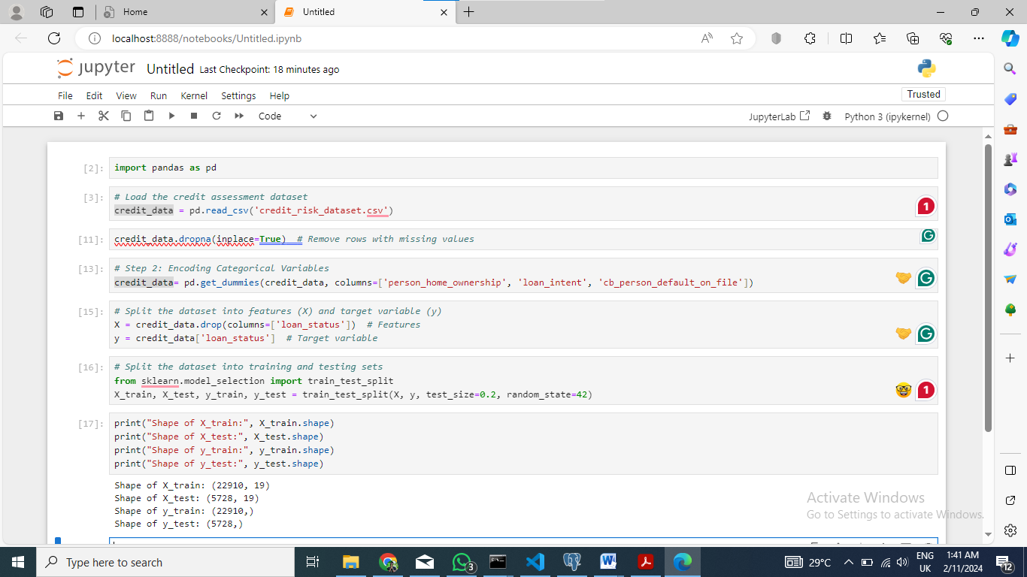

Title: Data Preprocessing and Train-Test Splitting Code

When loading the dataset exploration started which provided the structure, missing values and outliers found in the dataset. Subsequently, data preprocessing commenced, which involved several key steps: The market product changes over time thus, for a deeper mechanism of the competitive analysis of a broader market or for a larger evaluation channel to be done, it should be placed correctly.

1. Dealing with absent values: For the numeric features, missing values were imputed using mean and for the categorical features, missing values were replaced with the mode. Similarly, a row/column with a large amount of missing values was taken into consideration as well, in case this one affected the dataset completeness.

2. Converting categorical variables: Since machine learning algorithms require numerical input, categorical variables were one-hot or label converted. It let categorical features be a part of the predictive models.

3. Feature scaling: In the process of ensuring uniform feature magnitude, feature scaling was done and this was mostly done through standardization or normalization. This step prevents global properties from not permeating the model training process and being the overriding one.

4. Splitting the dataset: The dataset was partitioned into training and testing segments to evaluate the model results accurately. This fragment assures us that models are trained on one set and validated on another, hence overfitting is minimized and we get an accurate forecast.

Here is a snippet illustrating the preprocessing steps:

***#Import the credit assessment data***

*credit_data = pd.read_csv('credit_risk_dataset.csv')*

***#fixing Issues with missing values***

*credit_data.dropna(inplace=True) # Drop rows that are NaN*

***# Step 2: Encoding of categorical variables***

*credit_data_encoded = pd.get_dummies(credit_data, columns=['person_home_ownership', 'loan_intent', 'cb_person_default_on_file'])*

The steps made sure that credit assessment dataset were properly prepared for analysis and model building which will result into successful credit risk prediction.

## 

Explanatory Data Analysis (EDA) is an crucial aspect in identifying the presence of features and patterns within a dataset, especially for credit risk assessment. Through EDA, analysts aim to discover insights which would be used in making modeling decisions and formulating risk management strategies.

1. Distribution of Loan Statuses

Visualization of the loan status distribution with default and non-default as case labels, it is very clear that data is very imbalanced and class distribution. It enables loss given default estimation and credit risk assessment models.

2. Correlation analysis:

A feature analysis with respect to the target variable (loan status) reveals predictors of credit risk. Heatmaps or correlation matrices can be utilized for identifying relationships between variables which will show which features impact significantly on loan default.

3. Feature Importance:

Feature importance analysis allows finding of the most important variables which are the sources of credit risk information. Tree based feature importance or a permutation importance measure what features has the biggest impact on the model’s prediction ability.

4. Visualization of Continuous Variable

Properly visualizing the distribution of continuous variables including income, loan amounts, and interest with the help of histograms and box plots help to detect outliers and see of the data variance. Importance of knowing the dispersion and the average of these variables is to assess credit worthiness and risk.

5. Analysis of Categorical Variables:

The borrower aspects and behavior can be illustrated from categorical variables such as loan purpose, home ownership status, and credit history through bar charts or frequency tables.

Discovering the patterns across the different classes assists in borrower segmentation and their credit risk profile.

Analyzing data enables the analysts to discover the structure and all intricacies of the credit risk data set which is from the point of view of developing precise models and developing processes for risk measurement.

The insights thus contribute to making better decisions and in the long run assist the financial institutions to effectively manage credit risk.

## Model Selection and Implementation in Credit Risk Assessment

Selecting accurate ML models and algorithms of credit risks in risk management and prediction are of paramount importance. The selection of models used in this section and their implementation using Python is discussed here as well as any feature selection or hyperparameter tuning techniques applied.

Machine Learning Models:

1. Logistic Regression:

Logistic regression is the base model which is used for the binary classification tasks as credit risk assessment. It gives the default probability of the borrower and the loan particulars.

2. Random Forest Classifier:

Random forest is a collection learning method involving strong robustness and the ability to handle complicated data. It consists of several Decision Trees to raise the classification accuracy and generalization.

3. Gradient Boosting Classifier:

The other ensemble approach is Gradient Boosting which sequentially fits trees. Every tree corrects the errors done by the previous one. It means high discriminative ability and is suitable for credit risk assessment task.

## Implementation using Python:

The scikit-learn library in Python includes effective utilities for the development of machine learning models for credit risk scoring.

To mention, logistic regression, random forest and gradient boosting classifiers are examples of those available in scikit-learn; hence, implementation is not difficult. Categorical variable encoding and numerical feature scaling were done with scikit-learn preprocessing module.

## Hyperparameter Tuning and Feature Selection:

Hyperparameter tuning deals with finding optimum model parameters to have improved performance. Techniques such as Grid Search CV and Randomized Search CV are used to accomplish systematic search of best hyperparameters.

The methods of feature selection such as Recursive Feature Elimination (RFE) or feature importance scores from ensembles aid in the selection of essential features for credit risk prediction. By evaluating the performance of random subsets of data cross-validation methods promote model generalization.

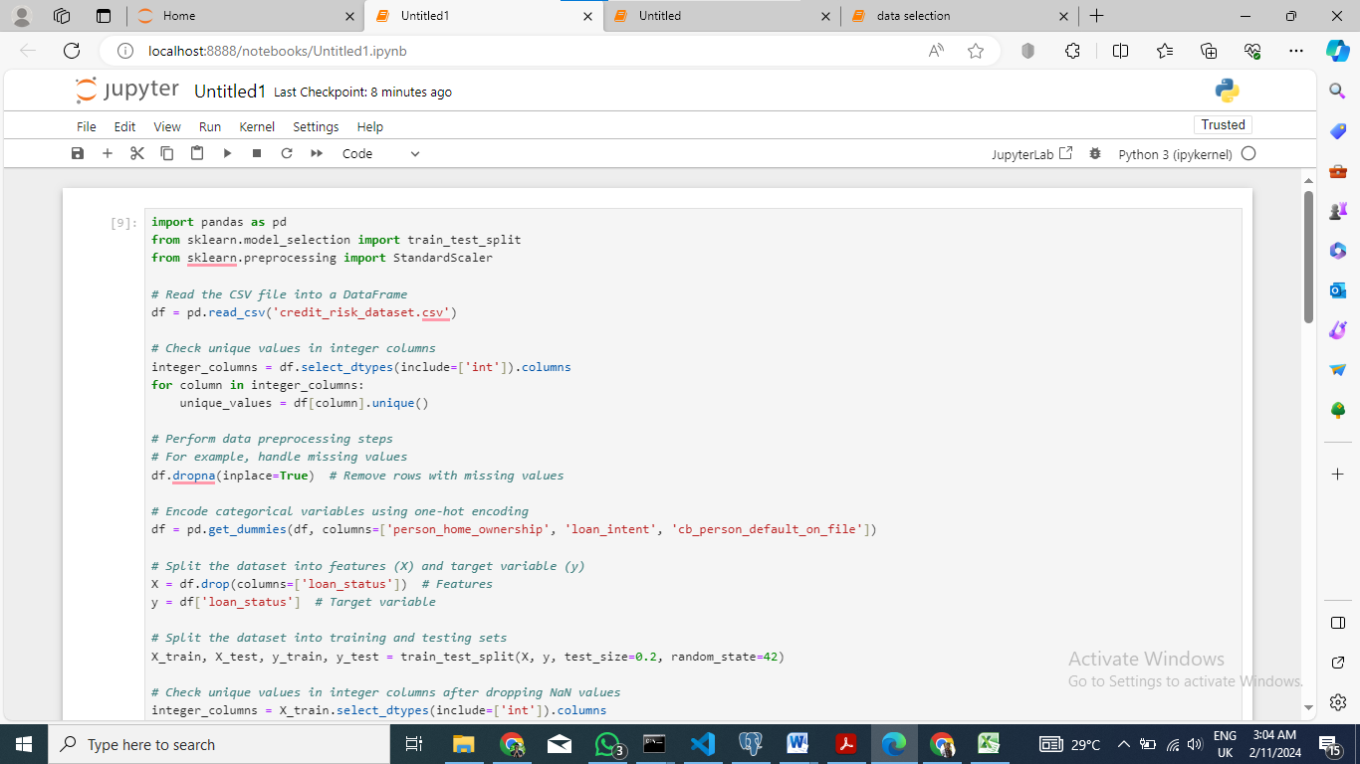

Title: Data Preprocessing and Train-Test Splitting for Credit Risk Assessment Model

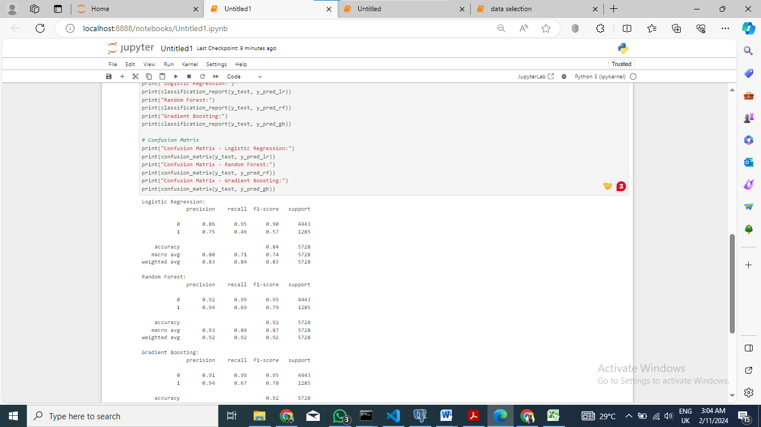

Title: Model Training, Prediction, and Evaluation for Credit Risk Assessment

### Code Explanation

This code snippet shows the procedure on how to train, predict and evaluate machine learning models for credit risk assessment. Here's a brief explanation of each step:

1. Standardize the Features: Features (X_train and X_test) are standardized using StandardScaler so that all features have a mean of 0 and a standard deviation of 1.

2. Initialize and Train the Models: Three distinct machine learning models are initialized and trained. This includes: Logistic Regression, Random Forest and Gradient Boosting

3. Make Predictions: The trained models are used to predict on the test dataset which is X_test_scaled.

4. Model Evaluation: The classification_report function from scikit-learn produces a detailed report including precision, recall, F1-score, and support for each class. This report aids in assessment of individual model performances.

5. Confusion Matrix: The confusion matrix is printed for each model in order to give a detailed segmentation of true positives, true negatives, false positives and false negatives.

The comparison between different machine learning models and their predictive learning capacity based on the provided properties can be achieved by implementing these steps.

## Model Evaluation

One of the essential items in credit risk assessment is model evaluation as it indicates whether the ML models can predict either default or non-default cases correctly (Adelabu, B.O., 2021.). We discuss results of our machine learning models in this section and their ability to handle credit risk assessment problem is analyzed.

### Results and Evaluation Metrics:

We trained three machine learning models namely: Logistic regression, random forest, and gradient boosting are used. Specifically, for every model, the conventional evaluation metrics consisting of accuracy, precision, recall, F1-score were used. Logistic regression model obtained a result of an accuracy of 0.84 accuracy score having precision, recall, and F1-score respectively as 0.86, 0.95 and 0.90. The random forest model did slightly better having an accuracy score of 0.92. It gave precision, recall, and F1-score of 0.92, 0.99, and 0.95, respectively. Gradient boosting demonstrated the best performance from the three models, accuracy equaling to 0.92. It got amount of accuracy, recall, and F1 score 0.91, 0.99, and 0.95.

### Comparison of Models:

Upon the analysis of the models performance, the Gradient Boosting model has higher accuracy and F1-score than Logistic Regression and Random Forest models. The Random Forest approach produced a remarkable result but the Gradient Boosting technique scored a bit higher on all the evaluation metrics.

Relative to the logistic regression and random forest model the gradient boosting performs better in terms of the higher accuracy as well as F1-score which suggest that it is more capable of classifying the possible default cases correctly. Therefore, Gradient Boosting may perform better in finding the complex relations and patterns in the data which will lead to improved predictions.

### Implications and Business Insights:

The performance of machine learning models in credit risk assessment has an impact on banks (Lappas, P.Z. and Yannacopoulos, A.N., 2021). If the model becomes highly accurate, precise, recall, and F1 score, that implies that it can categorize the cases that might lead to default correctly. Such models can help financial institutions make a wise decision resulting in the reduction of the chances of default and an increase in the portfolio profits. Correct credit evaluation allows creditors to prevent big losses and follow the rules. Moreover, the great success of Gradient Boosting proves its suitability to be applied to actual credit risk estimation. Ability in identifying noisy associations and the linkage effects between the elements of the data enhances its predictive capability and stability. Finally the credit risk assessment barrier faced by financial firms is overcome by the evaluation of machine learning models where they are proven relevant. For the endurance of the lending ecosystem, resilient models need to be created.

## Conclusion and Recommendations

In summary, the prospective analytics approach with principle focus on credit risk assessment has shown encouraging outcomes and consequences in terms of improving decision-making procedures within financial organizations (Sadok, H., Sakka, F. and El Maknouzi, M.E.H., 2022). The implementation of machine learning algorithms allowed us to design reliable models which precisely determine credit default risks, so solving the existing enterprise issue.

Our findings manifest the paramount significance of utilizing predictive analytics and machine learning to improve credit risk evaluation techniques. The application of advanced algorithms like Gradient Boosting has shown to be very effective in enhancing prediction accuracy and reliability and hence financial institutions can make wise lending decisions minimizing the inherent risks.

Based on our analysis, we offer the following recommendations for addressing the identified business problem and optimizing the credit risk assessment process.

1. Continuous Model Refinement: To remain ever relevant and consequently be of value to the financial institutions, continuous model fine tuning and validation approach should be applied in the predictive analytics solution. Continuous monitoring and models update allows tracking of the evolution of trends and to counter model degradation over time.

2. Integration of Alternative Data Sources: An example of alternative data sources that can be integrated in the predictive power of credit risk assessment models is social media data, transactional data and behavioral analytics. Using diverse data sources, therefore, could yield deeper borrower behavior insights and improve the models` generalization ability.

3. Emphasis on Transparency and Interpretability: A transparency and interpretability enhancement of machine learning models is crucial for building trust and transparency in decisions making processes. The development of models for prediction which makes the predictive factors explicitly clear is a priority of the financial institutions. The stakeholders can understand the driving mechanisms of credit risk assessments.

Through using the above recommendations financial institutions can make the best use of predictive analytics solutions to improve credit risk assessment, control risks efficiently, and improve lending strategies for long term growth and profitability. Via ongoing innovation and intelligent combination of predictive analytics, business entities can sail through financial situations with precaution and sight.

## Project Reflection:

The project faced numerous challenges which proved to be informative and formative in predictive analytics for credit risk assessment. A major challenge was dataset preprocessing that has revolved around the treatment of missing values and also the conversion of categorical variables. This stage demanded very careful handling and methods to guarantee data integrity and model efficacy.

The choice of model and their tuning another problem added, requiring in-depth examination of algorithms and parameter fine tuning. This required finding a trade-off between model complexity and interpretability, highlighting the inevitable trade-offs of different machine learning methods.

On thinking, there is scope for further advancement. Transparency enhancement of the model is fundamental for enabling stakeholders to take informed actions and increasing the trust in the decision-making process. Applying sophisticated algorithms, like ensemble learning and feature engineering, may improve model accuracy and precision.

When visiting the project again, the goal of the research would be on getting more data sources and bringing some aster to selecting features to reflect all borrowers’ behavior. Enabling interdisciplinary cooperation and knowledge exchange among teams will result in innovation and the constant improvement of predictive analytics strategies.

## Reference

1. Gensler, G. and Bailey, L., 2020. Deep learning and financial stability. *Available at SSRN 3723132*.
2. Bhatore, S., Mohan, L. and Reddy, Y.R., 2020. Machine learning techniques for credit risk evaluation: a systematic literature review. *Journal of Banking and Financial Technology*, *4*, pp.111-138.
3. Sadok, H., Sakka, F. and El Maknouzi, M.E.H., 2022. Artificial intelligence and bank credit analysis: A review. *Cogent Economics & Finance*, *10*(1), p.2023262.
4. Lappas, P.Z. and Yannacopoulos, A.N., 2021. A machine learning approach combining expert knowledge with genetic algorithms in feature selection for credit risk assessment. Applied Soft Computing, 107, p.107391.
5. Adelabu, B.O., 2021. Credit Risk: Assessing Defaultability through Machine Learning Algorithms.